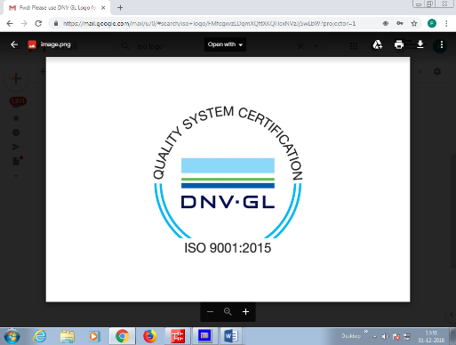**R.M.K. ENGINEERING COLLEGE**

(An Autonomous Institution)

**R.S.M. Nagar, Kavaraipettai-601 206**

**DEPARTMENT OF INFORMATION TECHNOLOGY**

**HOTEL MANAGEMENT PROJECT**

# A VACATION MINI PROJECT REPORT

# APRIL 2021

***Submitted by***

**MENTA LAKSHMI SATHWIKA**

**REG NO: 111720202023**

***Under the Guidance of***

**Ms. JHANSI IDA.S**

**DEPARTMENT OF INFORMATION TECHNOLOGY**

**TABLE OF CONTENTS**

|  |  |  |
| --- | --- | --- |
| **S.NO** | **CONTENTS** | **PAGE.NO** |
| **1** | **ABSTRACT** | **3** |
| **2** | **PROTOTYPE/BLOCK DIAGRAM** | **4** |
| **3** | **MODULE DESCRIPTION** | **4** |
| **4** | **TECHNOLOGY STACK** | **5** |
| **5** | **SCREEN SHOTS** | **9** |
| **6** | **SAMPLE CODING** | **6** |
| **7** | **CONCLUSION**  **(FUTURE ENHANCEMENTS)** | **13** |
| **8** | **REFERENCES** | **13** |

“HOTEL MANAGEMENT SYSTEM” Is a typical luxury hotel requires a management system to control its various operations such as maintaining account of all people in its domain of serovarious needs of cu**ABSTRACT:**stomers and also achieving **increased** efficiency in

**“HOTEL MANAGEMENT SYSTEM” Is a typical luxury hotel requires a management system to control its various operations such as maintaining account of all people in its domain of services, attending to various needs of customers and also achieving increased efficiency in the over all working of the hotel itself.in the present time there is a grate rush in hotels, as thesahavebecome necessities for middle and upper class of the society.People travel a lot,staying hotels,and goes to the hotels for functions,meeting and refreshments.The booking is manually done using paper work and direct human language communication by mouth to manage the hotel. this delays information transmission in the hotel.Booking is done through phone calls or through visit to the hotel booking office.**

**The hotel management system aim's simpler a staff's interaction with the various modules of the hotel and ease the process of acquiring information and providing services. the system can be accessed by the admin and customers but the highest priority given to the admin that are allocated a login id and password. it will also allow cut in the operational cost's of the hotel.Hotel management system provides various rooms booking services,managing the information of customers,description regarding the room booking.The proposed system enables automated data entry methods and enables fast and easy retrieval of guest records and data for fast reference activities**

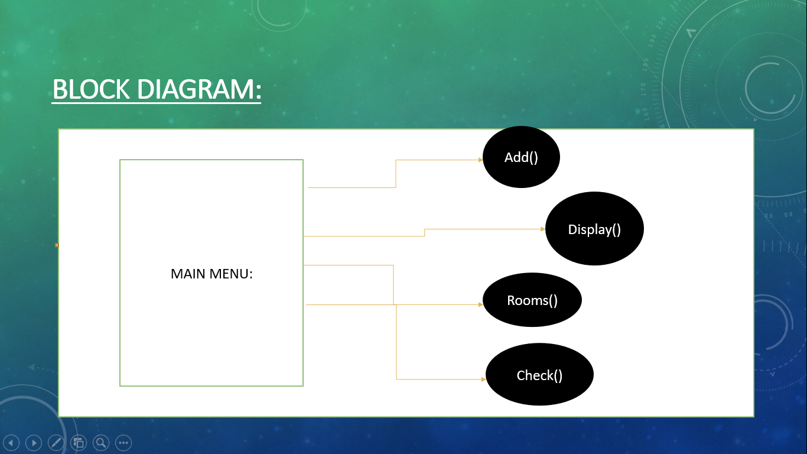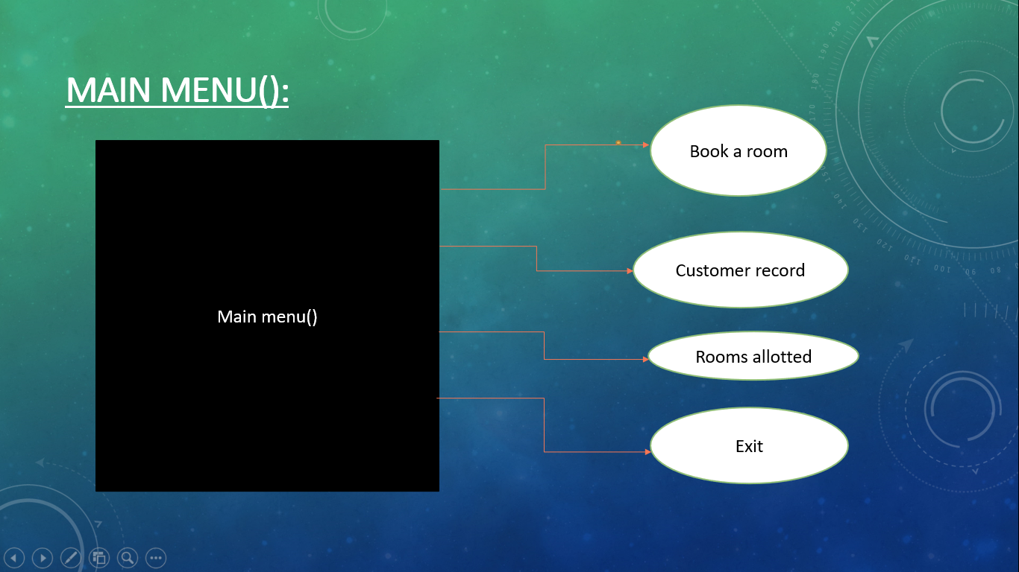**TECHNOLOGY STACK:**

**HARDWARE REQUIREMENTS:**

**RAM:1GB**

**HARD DISK:128GB**

**PROCESSOR:1.50GHZ OR ABOVE**

**SOFTWARE REQUIREMENTS:**

**OPERATING SYSTEM:WINDOWS 10**

**SAMPLE CODE:**

#include<iostream>

#include<fstream>

#include<stdio.h>

#include<conio.h>

using namespace std;

class hotel

{

int room_no;

char name[30];

char address[100];

char phone[10];

public:

void main_menu(); //to dispay the main menu

void add(); //to book a room

void display(); //to display the customer record

void rooms(); //to display alloted rooms

int check(int); //to check room status

};

void hotel::main_menu()

{

int choice;

while(choice!=4)

{

cout<<"\n\t\t\t\t*************";

cout<<"\n\t\t\t\t* MAIN MENU *";

cout<<"\n\t\t\t\t*************";

cout<<"\n\n\n\t\t\t1.Book A Room";

cout<<"\n\t\t\t2.Customer Record";

cout<<"\n\t\t\t3.Rooms Allotted";

cout<<"\n\t\t\t4.Exit";

cout<<"\n\n\t\t\tEnter Your Choice: ";

cin>>choice;

switch(choice)

{

case 1: add();

break;

case 2: display();

break;

case 3: rooms();

break;

case 4: break;

default:

{

cout<<"\n\n\t\t\tWrong choice!!!";

cout<<"\n\t\t\tPress any key to continue!!";

}

}

}

}

void hotel::add()

{

int r,flag=0;

ofstream fout("Record.dat",ios::app);

cout<<"\n Enter Customer Detalis";

cout<<"\n **********************";

cout<<"\n\n Room no: ";

cin>>r;

flag=check(r);

if(flag)

cout<<"\n Sorry..!!!Room is already booked";

else

{

room_no=r;

cout<<" Name&";

gets(name);

cout<<"Address: ";

gets(address);

cout<<" Phone No: ";

gets(phone);

fout.write((char*)this,sizeof(hotel));

cout<<"\n Room is booked!!!";

}

cout<<"\n Press any key to continue!!";

fout.close();

}

void hotel::display()

{

ifstream fin("Record.dat",ios::in);

int r,flag=0;

cout<<"\n Enter room no: ";

cin>>r;

while(!fin.eof())

{

fin.read((char*)this,sizeof(hotel));

if(room_no==r)

{

cout<<"\n Cusromer Details";

cout<<"\n ****************";

cout<<"\n\n Room no: "<<room_no;

// cout<<"\n Name: "<<name;

cout<<"\nName&Address: "<<address;

cout<<"\n Phone no: "<<phone;

flag=1;

break;

}

}

if(flag==0)

cout<<"\n Sorry Room no. not found or vacant!!";

cout<<"\n\n Press any key to continue!!";

fin.close();

}

void hotel::rooms()

{

ifstream fin("Record.dat",ios::in);

cout<<"\n\t\t\tList Of Rooms Allotted";

cout<<"\n\t\t\t*********************";

cout<<"\n\n Room No.\tName&Address\t\tPhone No.\n";

while(!fin.eof())

{

fin.read((char*)this,sizeof(hotel));

cout<<"\n\n "<<room_no<<"\t\t"<<name;

cout<< address<<"\t\t"<<phone;

}

cout<<"\n\n\n\t\t\tPress any key to continue!!";

fin.close();

}

int hotel::check(int r)

{

int flag=0;

ifstream fin("Record.dat",ios::in);

while(!fin.eof())

{

fin.read((char*)this,sizeof(hotel));

if(room_no==r)

{

flag=1;

break;

}

}

fin.close();

return(flag);

}

int main()

{

hotel h;

cout<<"\n\t\t\t****************************";

cout<<"\n\t\t\t* HOTEL MANAGEMENT PROJECT *";

cout<<"\n\t\t\t****************************";

h.main_menu();

return

**SCREENSHOTS:**

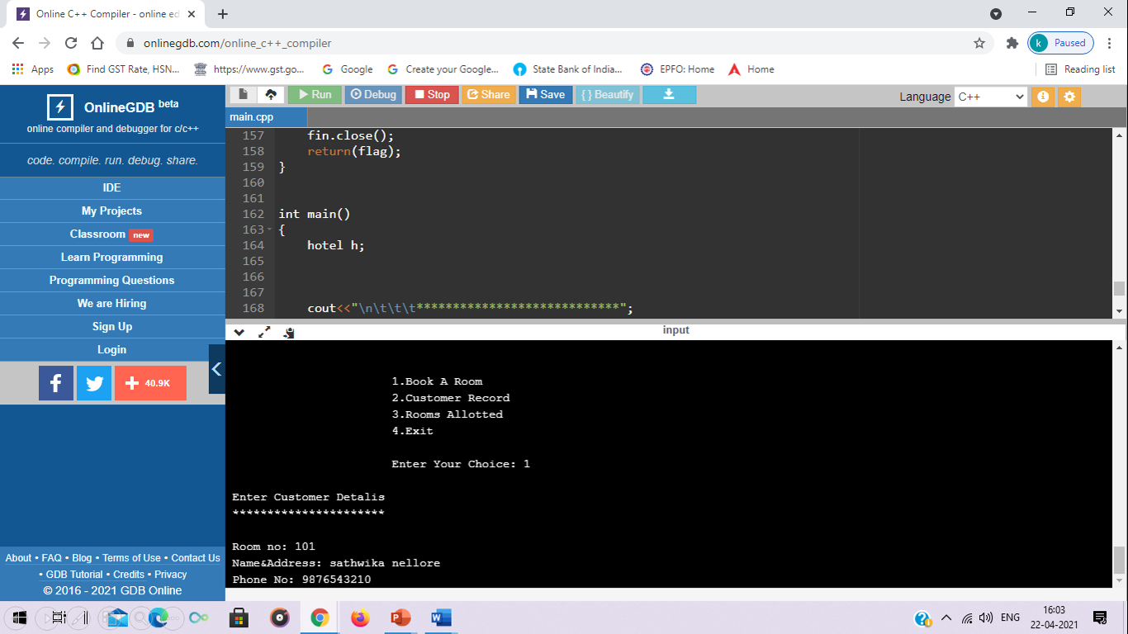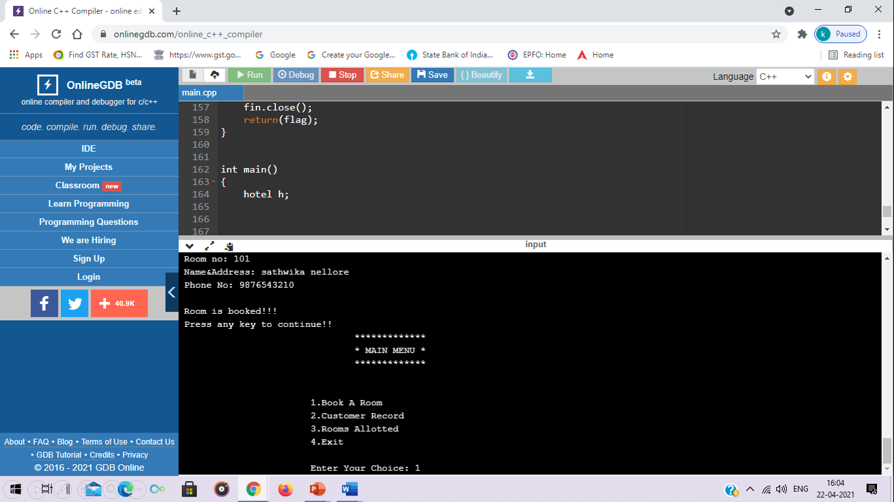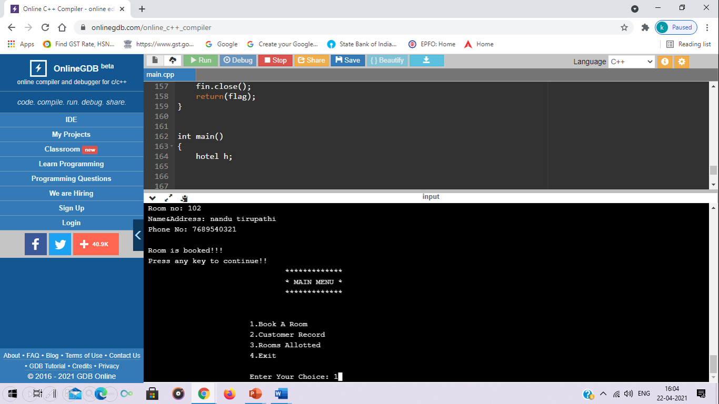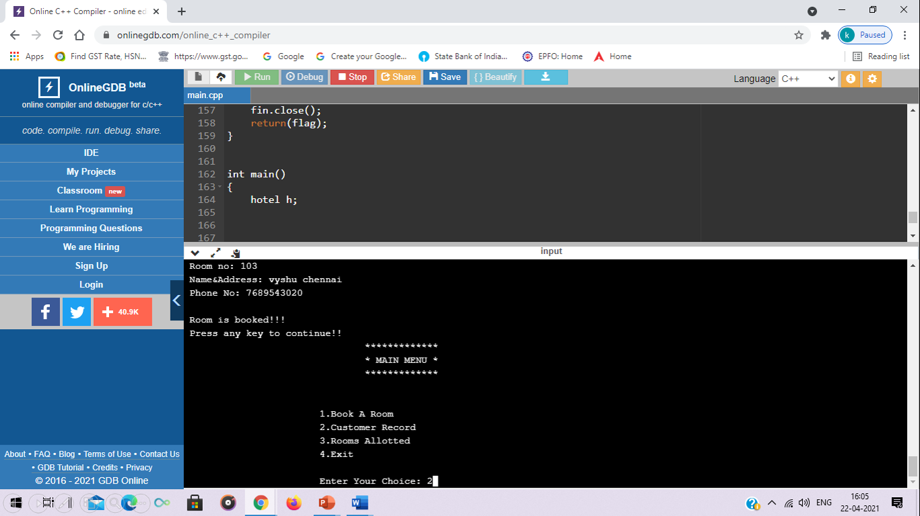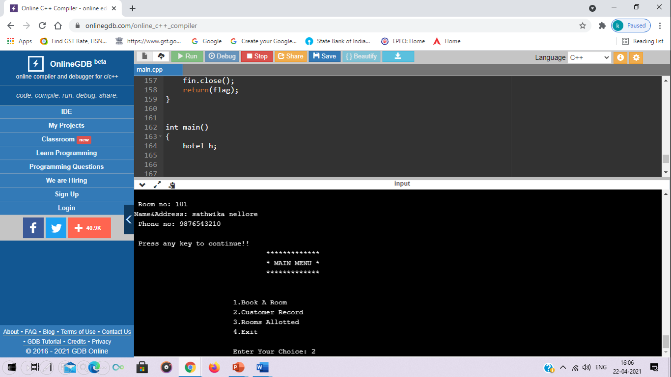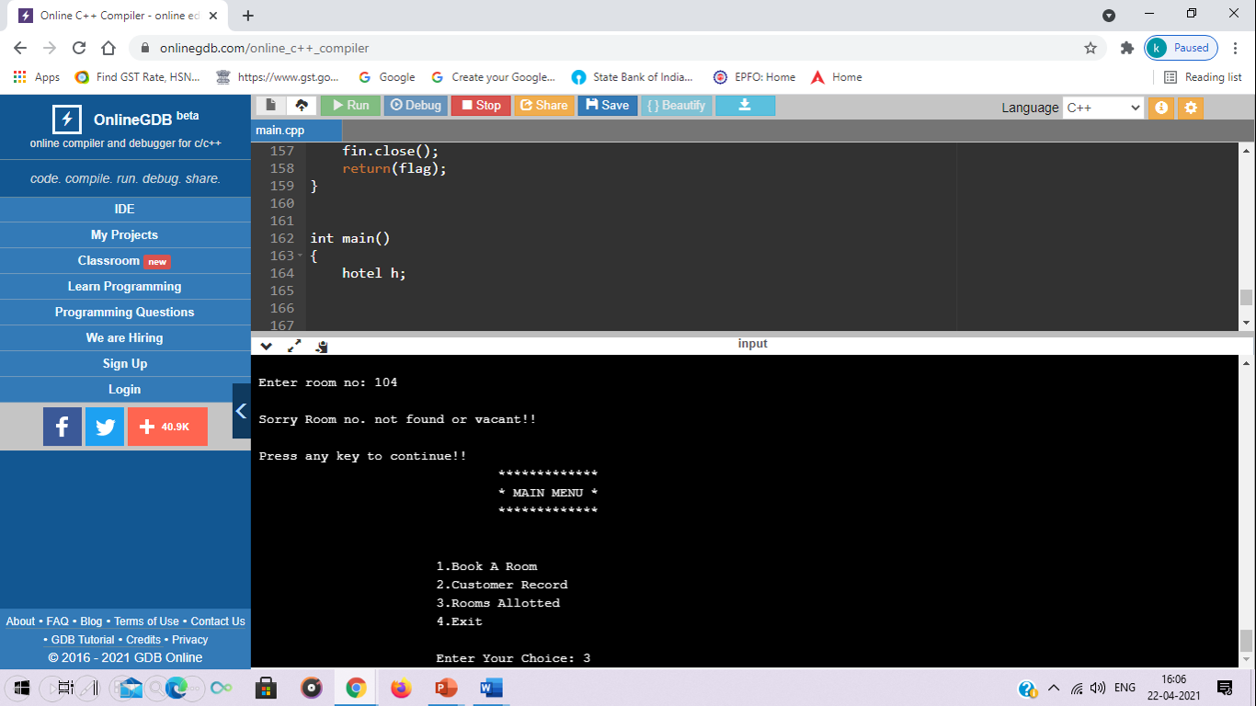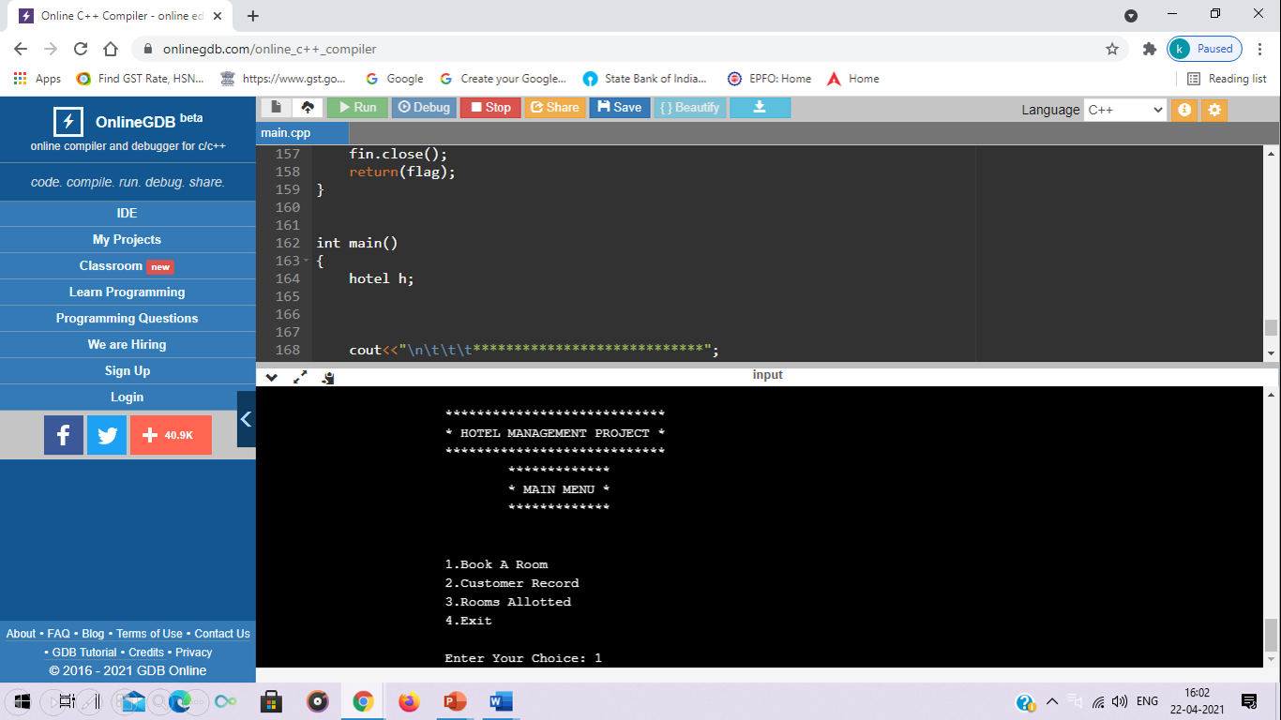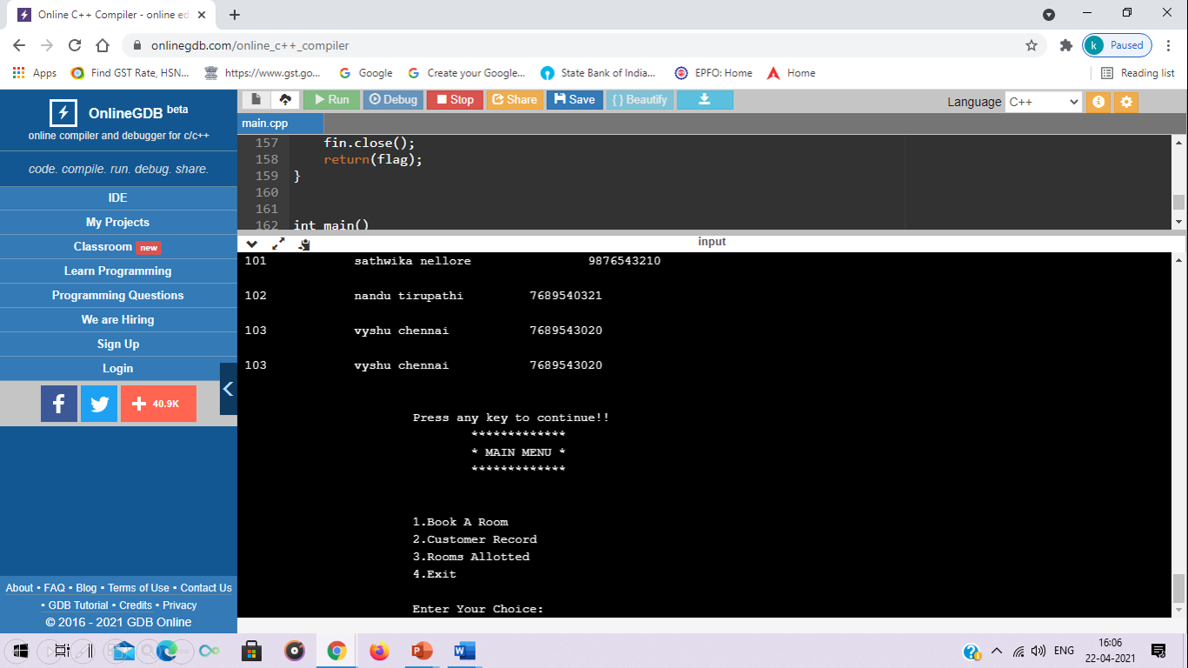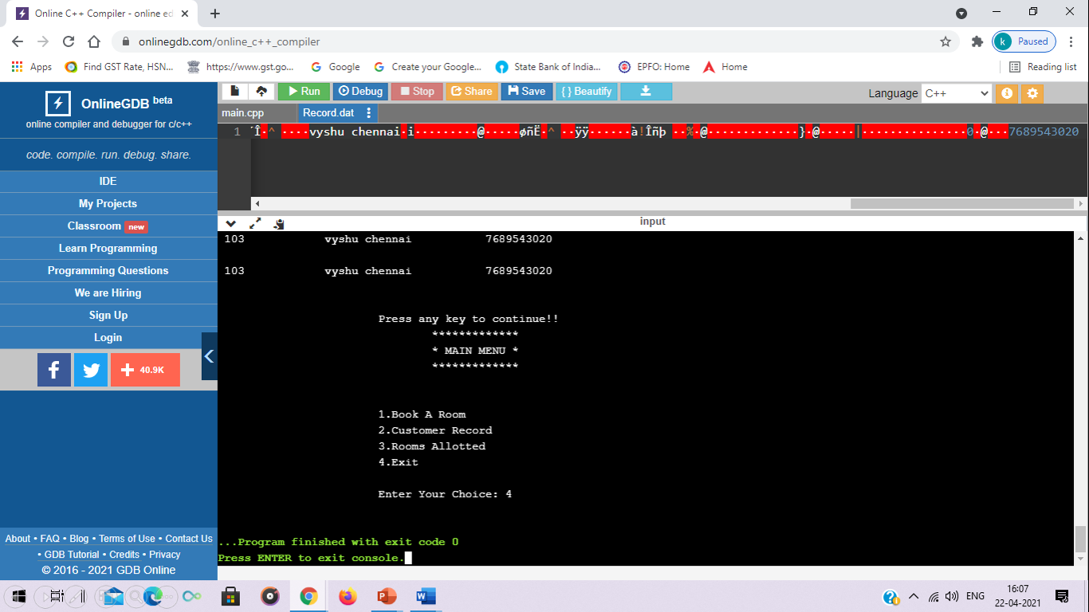

**CONCLUSION:**

WITH THE HELP OF THIS CODE WE CAN BOOK A ROOM IN HOTEL THROUGH ONLINE MODE

**REFERENCES:**

THROGH GOOGLE,YOUTUBE,BROTHER AND SISTER